* **[How to embed a video on a SharePoint page](https://sharepoint.rackspace.com/learning/articles/Pages/SharePoint-2013--how-to-embed-a-video-on-a-SharePoint-page.aspx)**

1. From your SharePoint site, edit any page you would like, in this example I will edit my home page.   
  
2. In the upper left click **Page**.

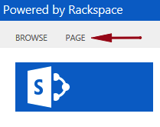

3. On the ribbon click **Edit**.

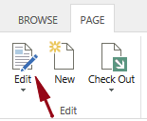

4. The page will now be opened for editing, place your cursor in any whitespace within the outermost gray line (I know, not the best way to describe it but you get the point).

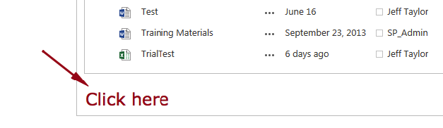

5. On the ribbon click the **INSERT** tab.

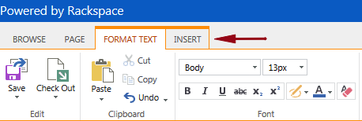

6. In the Media section click **Video and Audio** and select **Embed** from the drop-down.

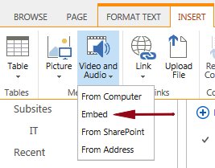

7. Locate the video you would like to embed, in this example I will use the  “**SharePoint: 2013 Getting Started (Tutorial)**” from youtube and copy the Embed code.

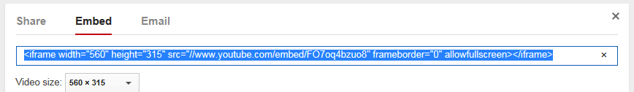

8. Go back to your SharePoint site and paste the code in the **Embed** window.

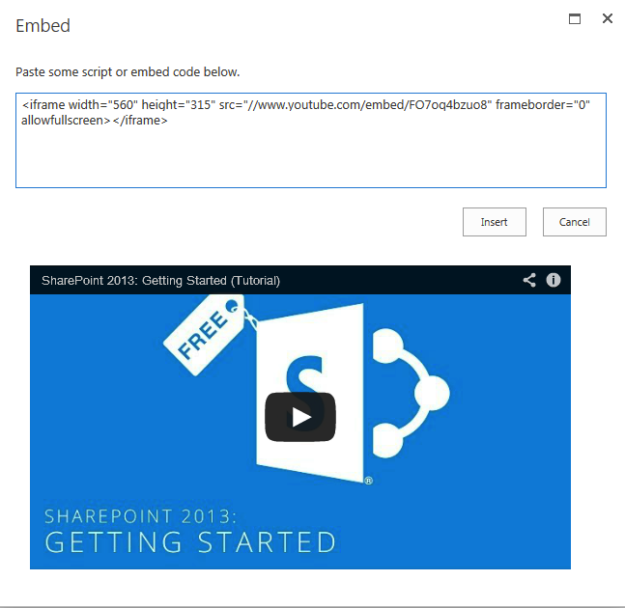  
  
9. A preview of the video being embedded will be displayed, if it looks correct click **Insert**.  
  
https://sharepoint.rackspace.com/PublishingImages/Pages/sp2013%20how%20to%20embed%20a%20video%20on%20a%20SharePoint%20page/embedvideo8.png

The video will be inserted on the page but we still need to save our changes.

10. On the ribbon click **Page**.

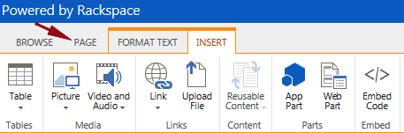

11. In the Edit section click **Save**.

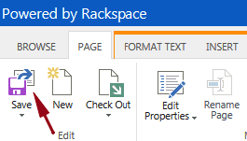

12. That’s it!  You have successfully embedded a video on a SharePoint page.